Pickford’s House Museum
Welcome to Pickford’s House! This is a house from the 1700s that was designed by Joseph Pickford (an architect). You will come into the main entrance to the Museum at the side of the house. If you parked in the carpark you will go through a gap and then to the door (picture 3).

You can leave your coat, bag and packed lunch in the baskets in the welcome area:

There is a sensory bag that you can request. You can use it during your visit if you want to:
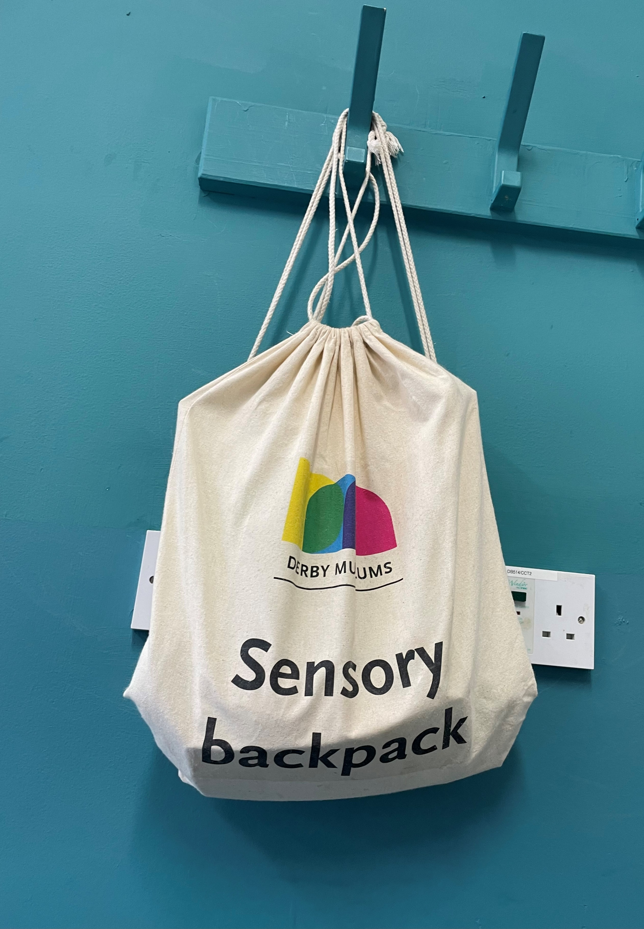

Your session will take place in the galleries and you might also be in the garden.

Other important things
There are lots of steps here and no lifts. It can make getting around hard if you struggle with stairs. There are toilets on the first and second floor:

There isn’t much space to eat lunch at Pickford’s House so you might eat lunch back at school, in the Pickford House Garden, or somewhere else.

Staff will be able to help you if you want more information or want to ask any questions.
We hope you have a good time at Pickford’s House!
Note for staff: We want everyone to feel happy and welcomed at Derby Museums. If you need any help, please ask any staff on the day of your visit. If you need any other help, have any questions or would like further advice then you can email learn@derbymuseums.org or call 01332 641901 and ask for a member of the learning team. We’ll try our best to help you.

