Derby Museums and Art Gallery- Viking and Anglo-Saxon Session
Welcome to Derby Museum and Art Gallery.
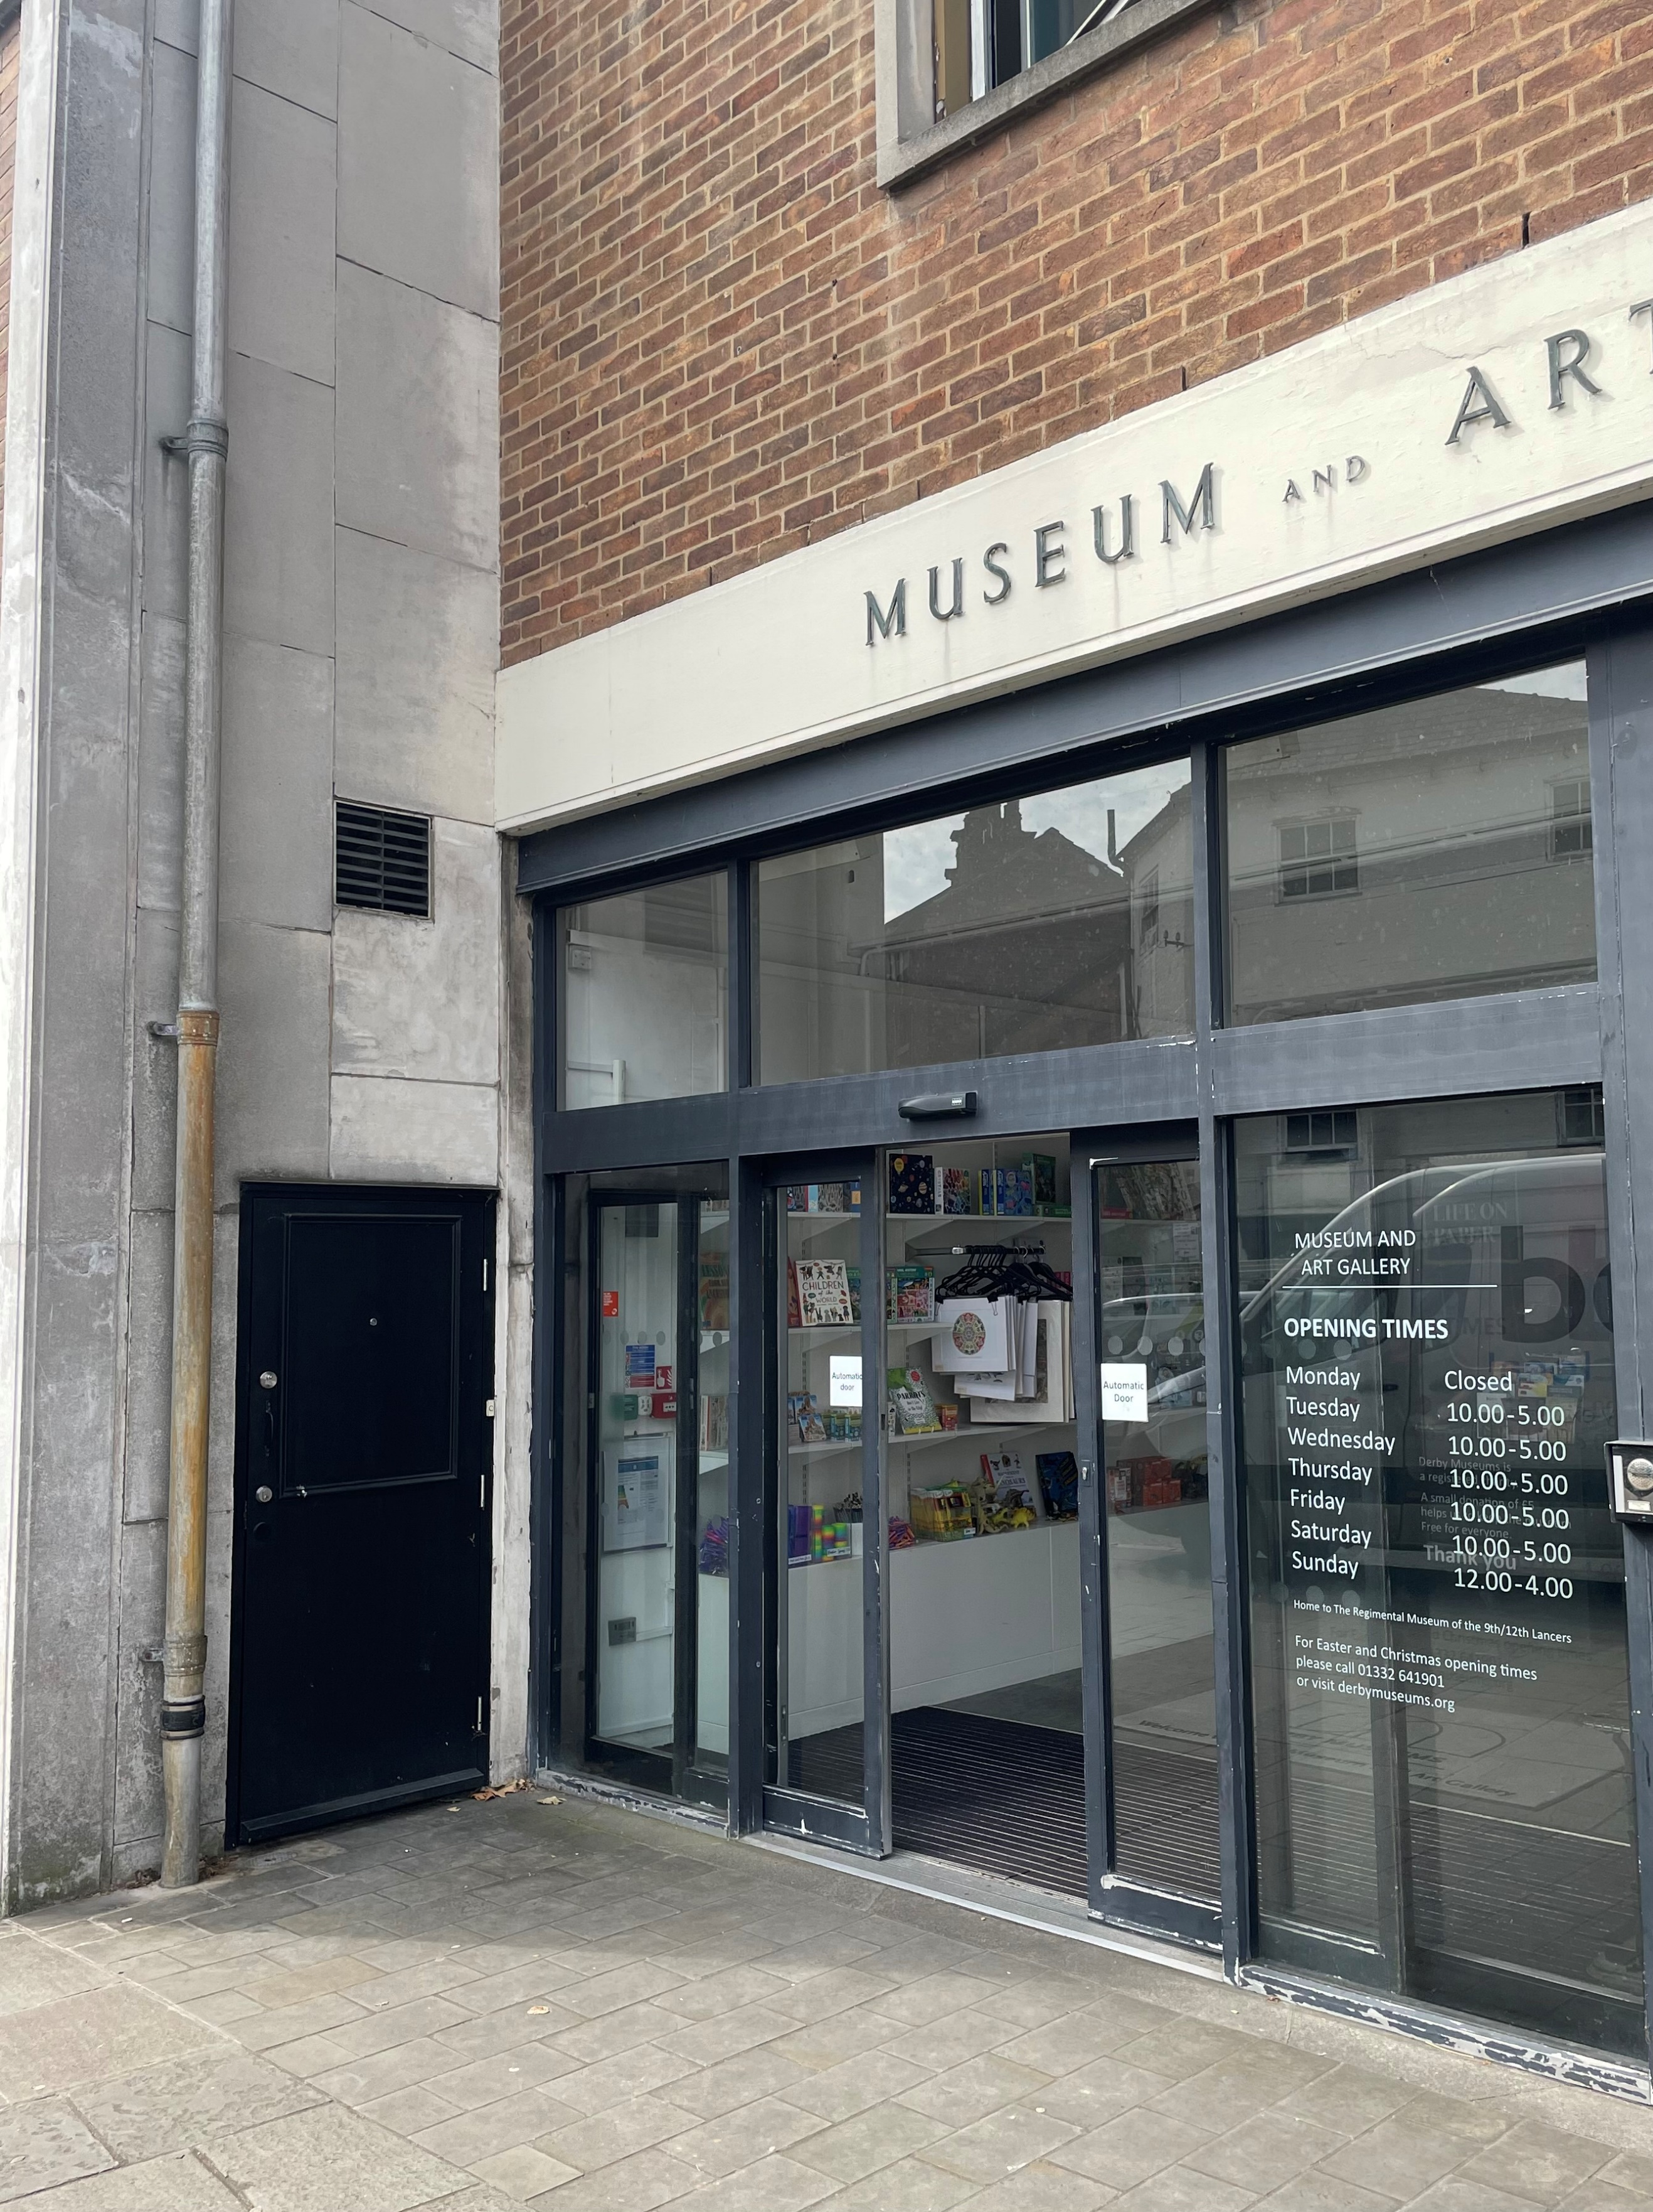
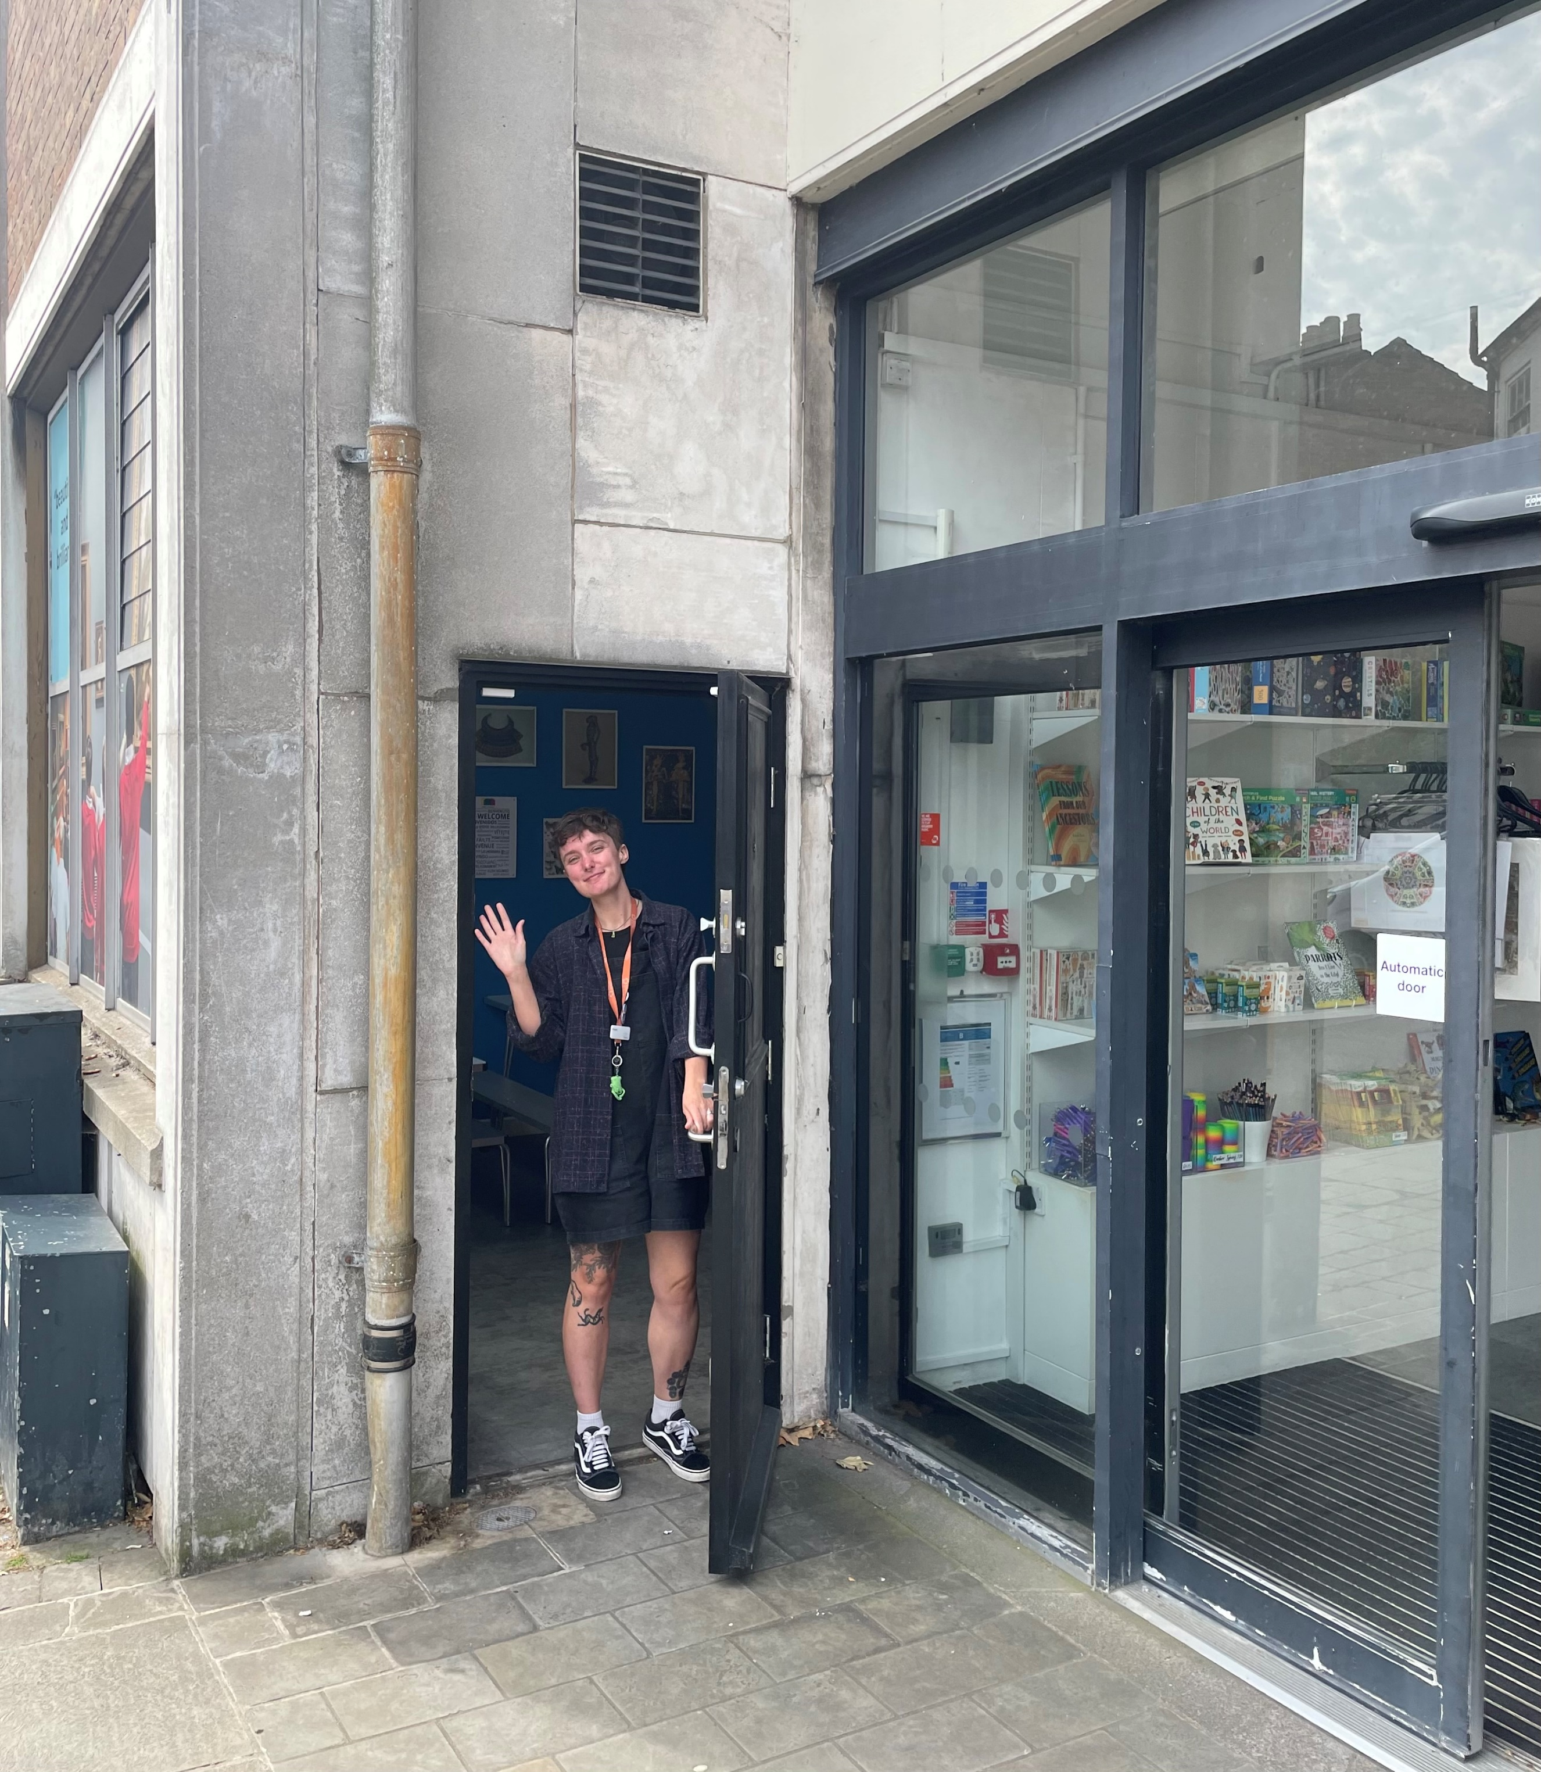

This is the entrance to the Museum. You can come in through the small black door just by the main entrance.

You can leave your coat, bag and packed lunch in the trolleys in The Lunchroom. This room is where you will eat your packed lunch.
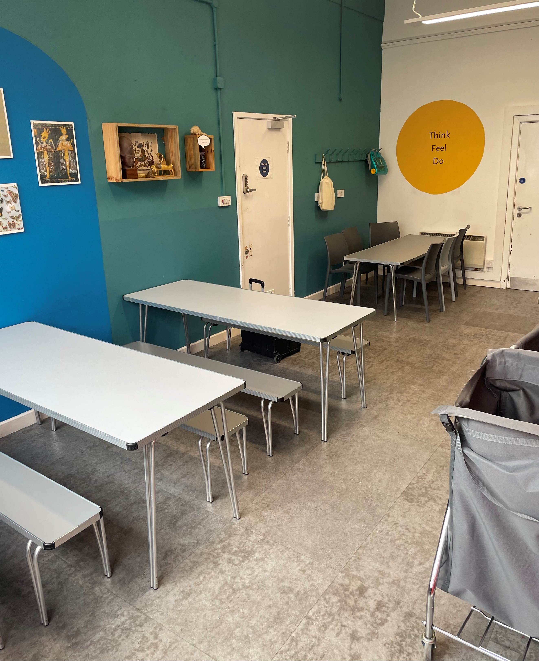
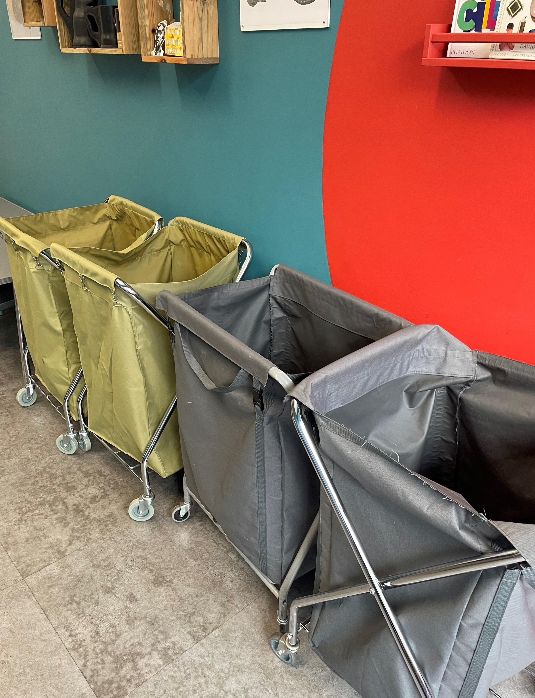

The Viking Session will take place in the Archaeology Gallery. The Session will start with a when the class are sitting down, and a member of museum staff will ask questions and write information on a flipchart.
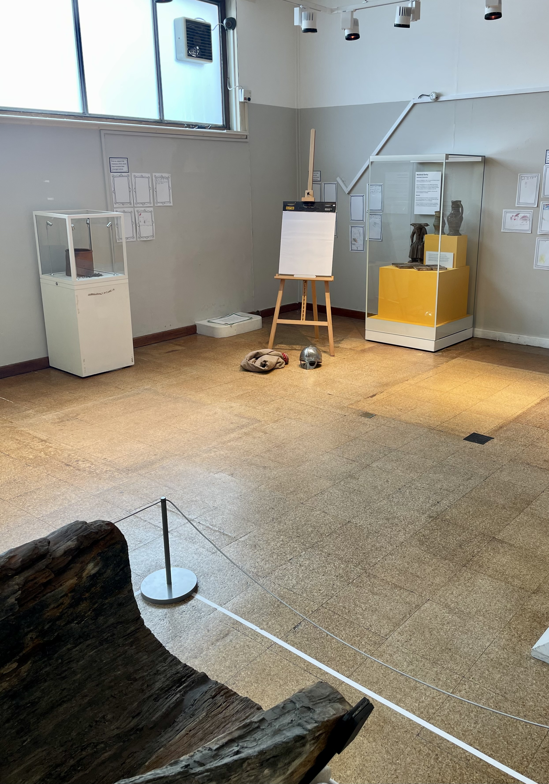
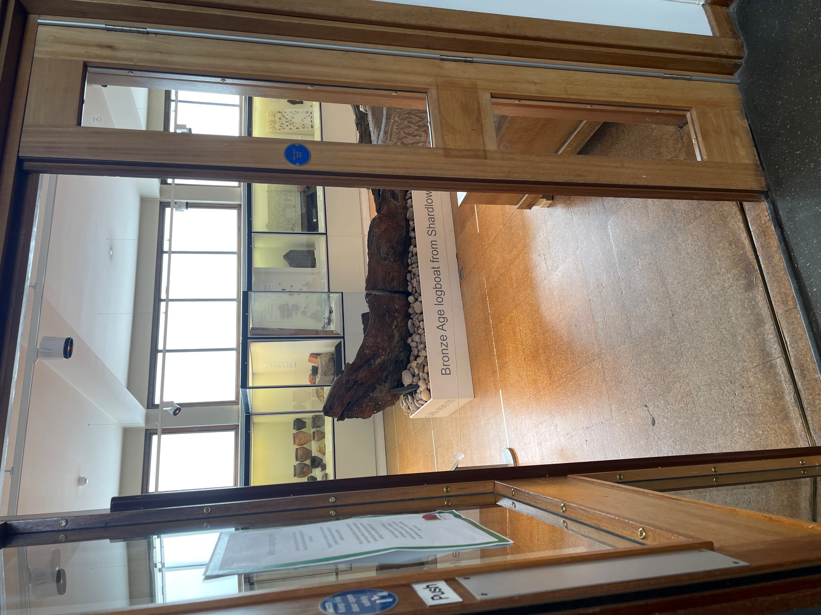

After sitting and listening you can move around and can do 3 activities:
- Looking and handling Viking Objects
- Learning about a Viking Burial
(It is not a real skeleton. It is a plastic skeleton.)
- Learning about Viking Rune Symbols
Here is a picture of the Viking Object and Viking Burial activities:
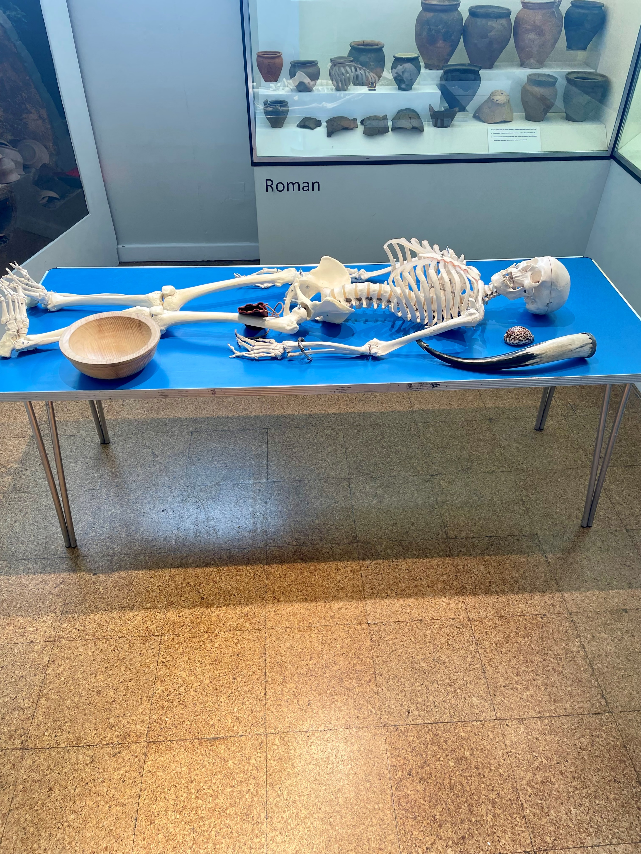
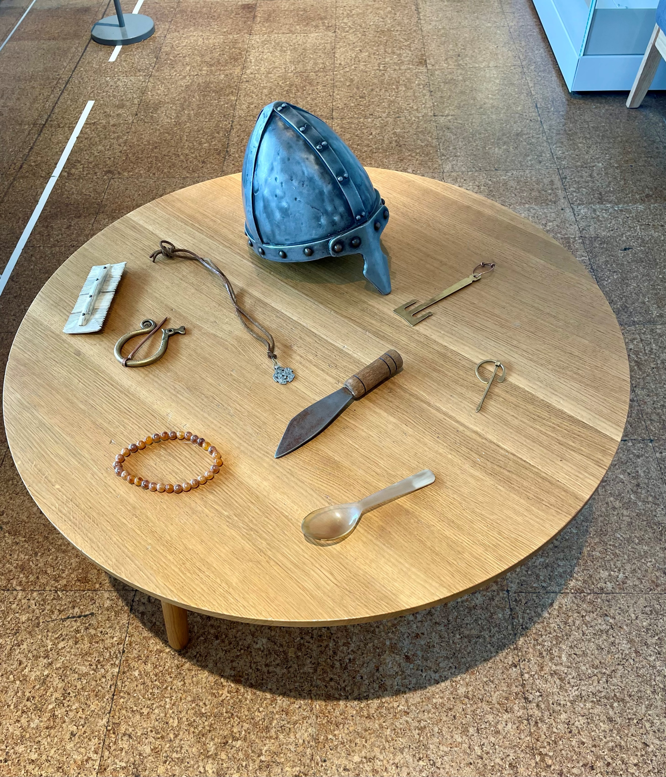

After the activities you can go to the Activity Room and, if you wish to, you can use clay to make a replica of Thor’s Hammer.
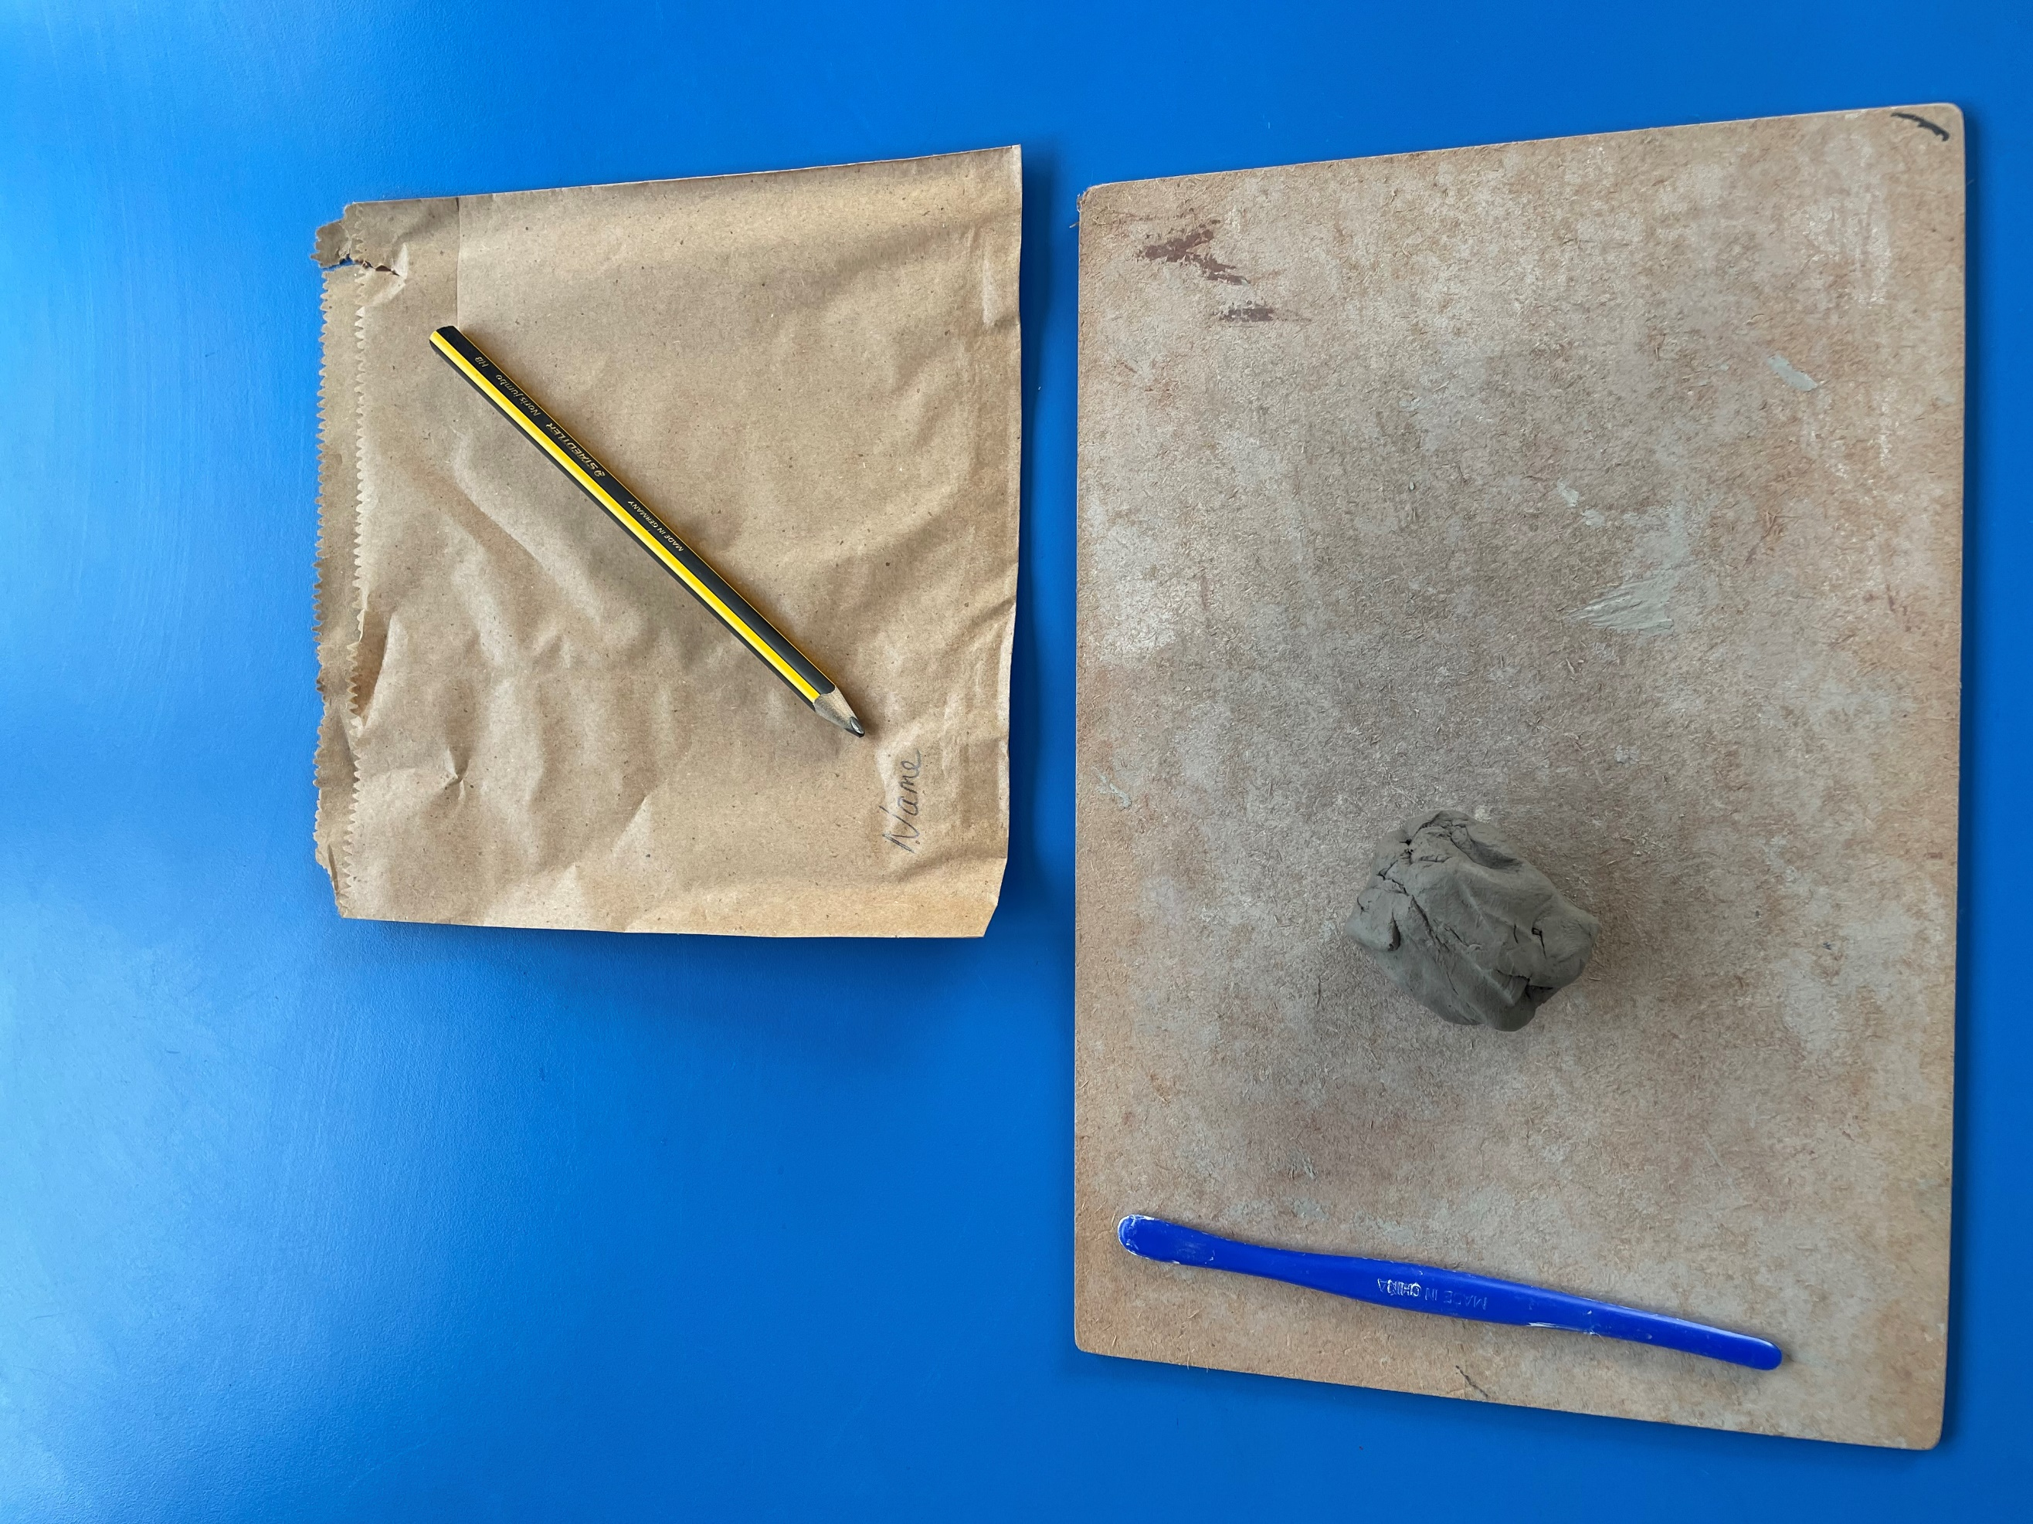
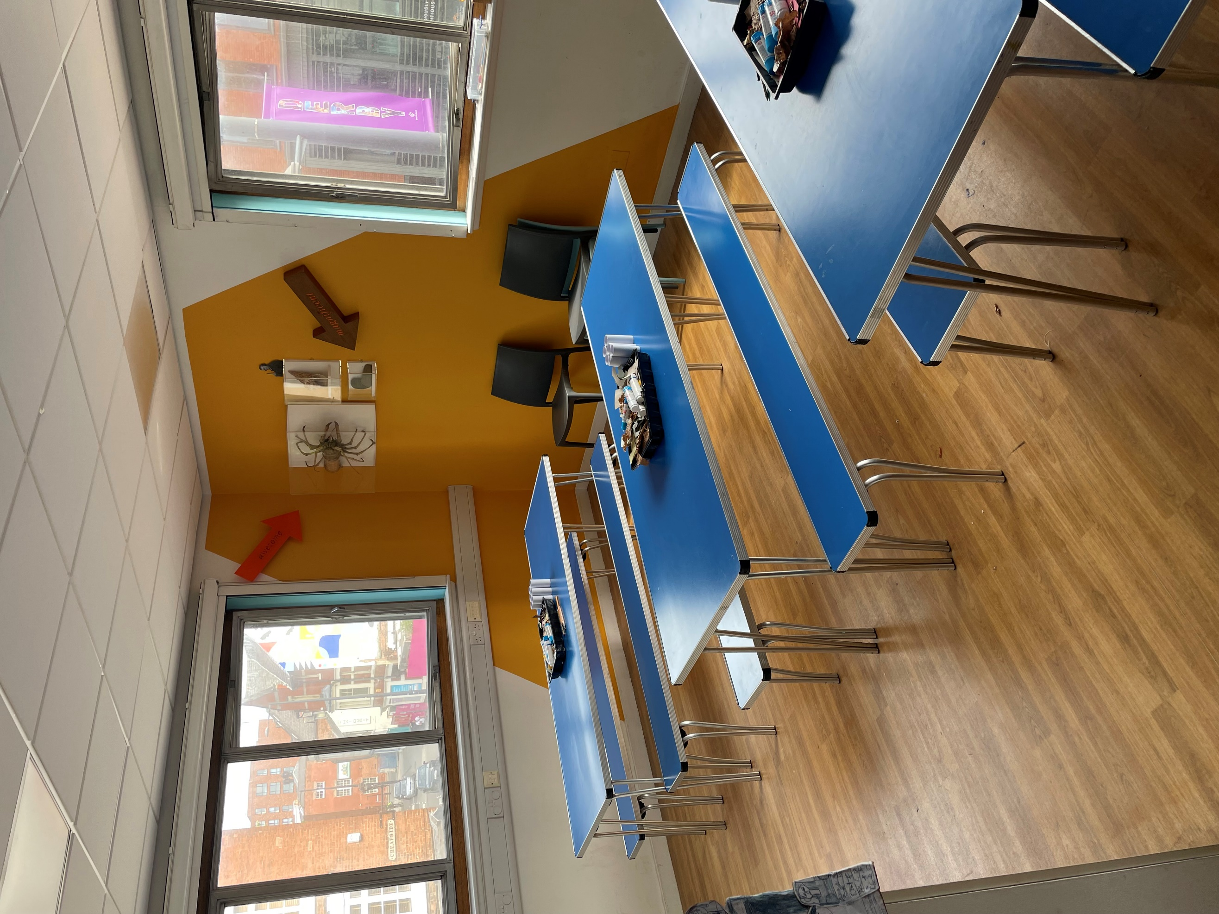

After the activity you can wash your hands.

Other important things
There is a nice accessible toilet on the 1st floor near the activity room. You go through the door on the left of the activity room to get to it. It has a fan. It has a hand dryer that can be turned off if you need to.
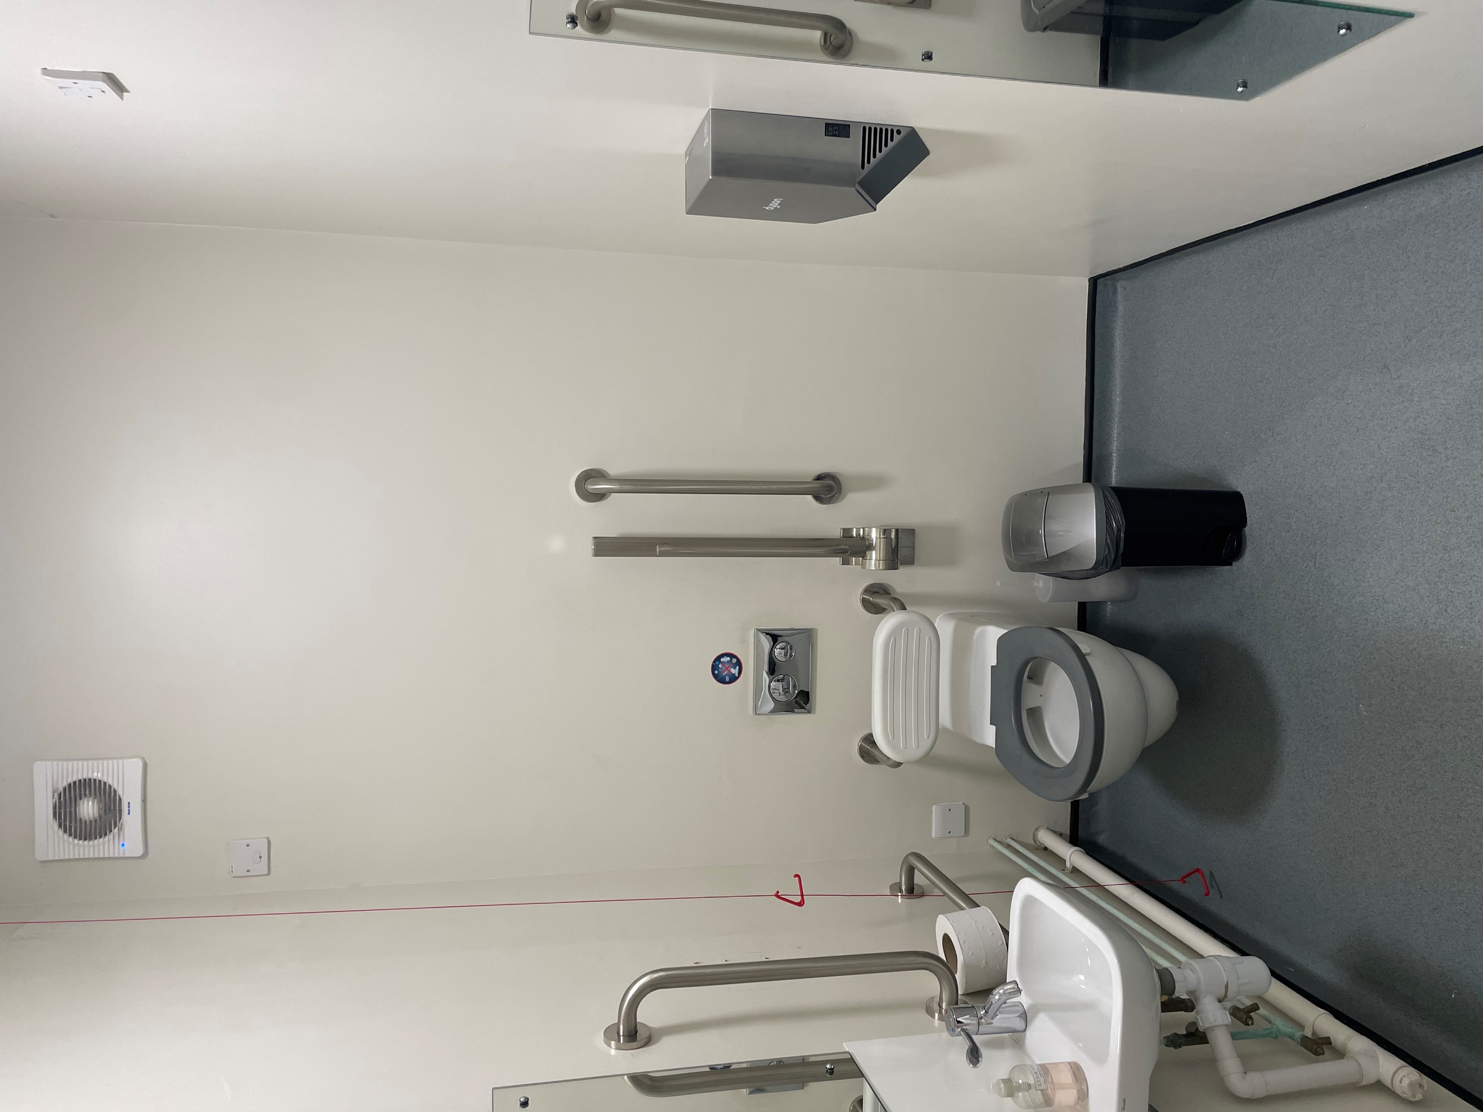
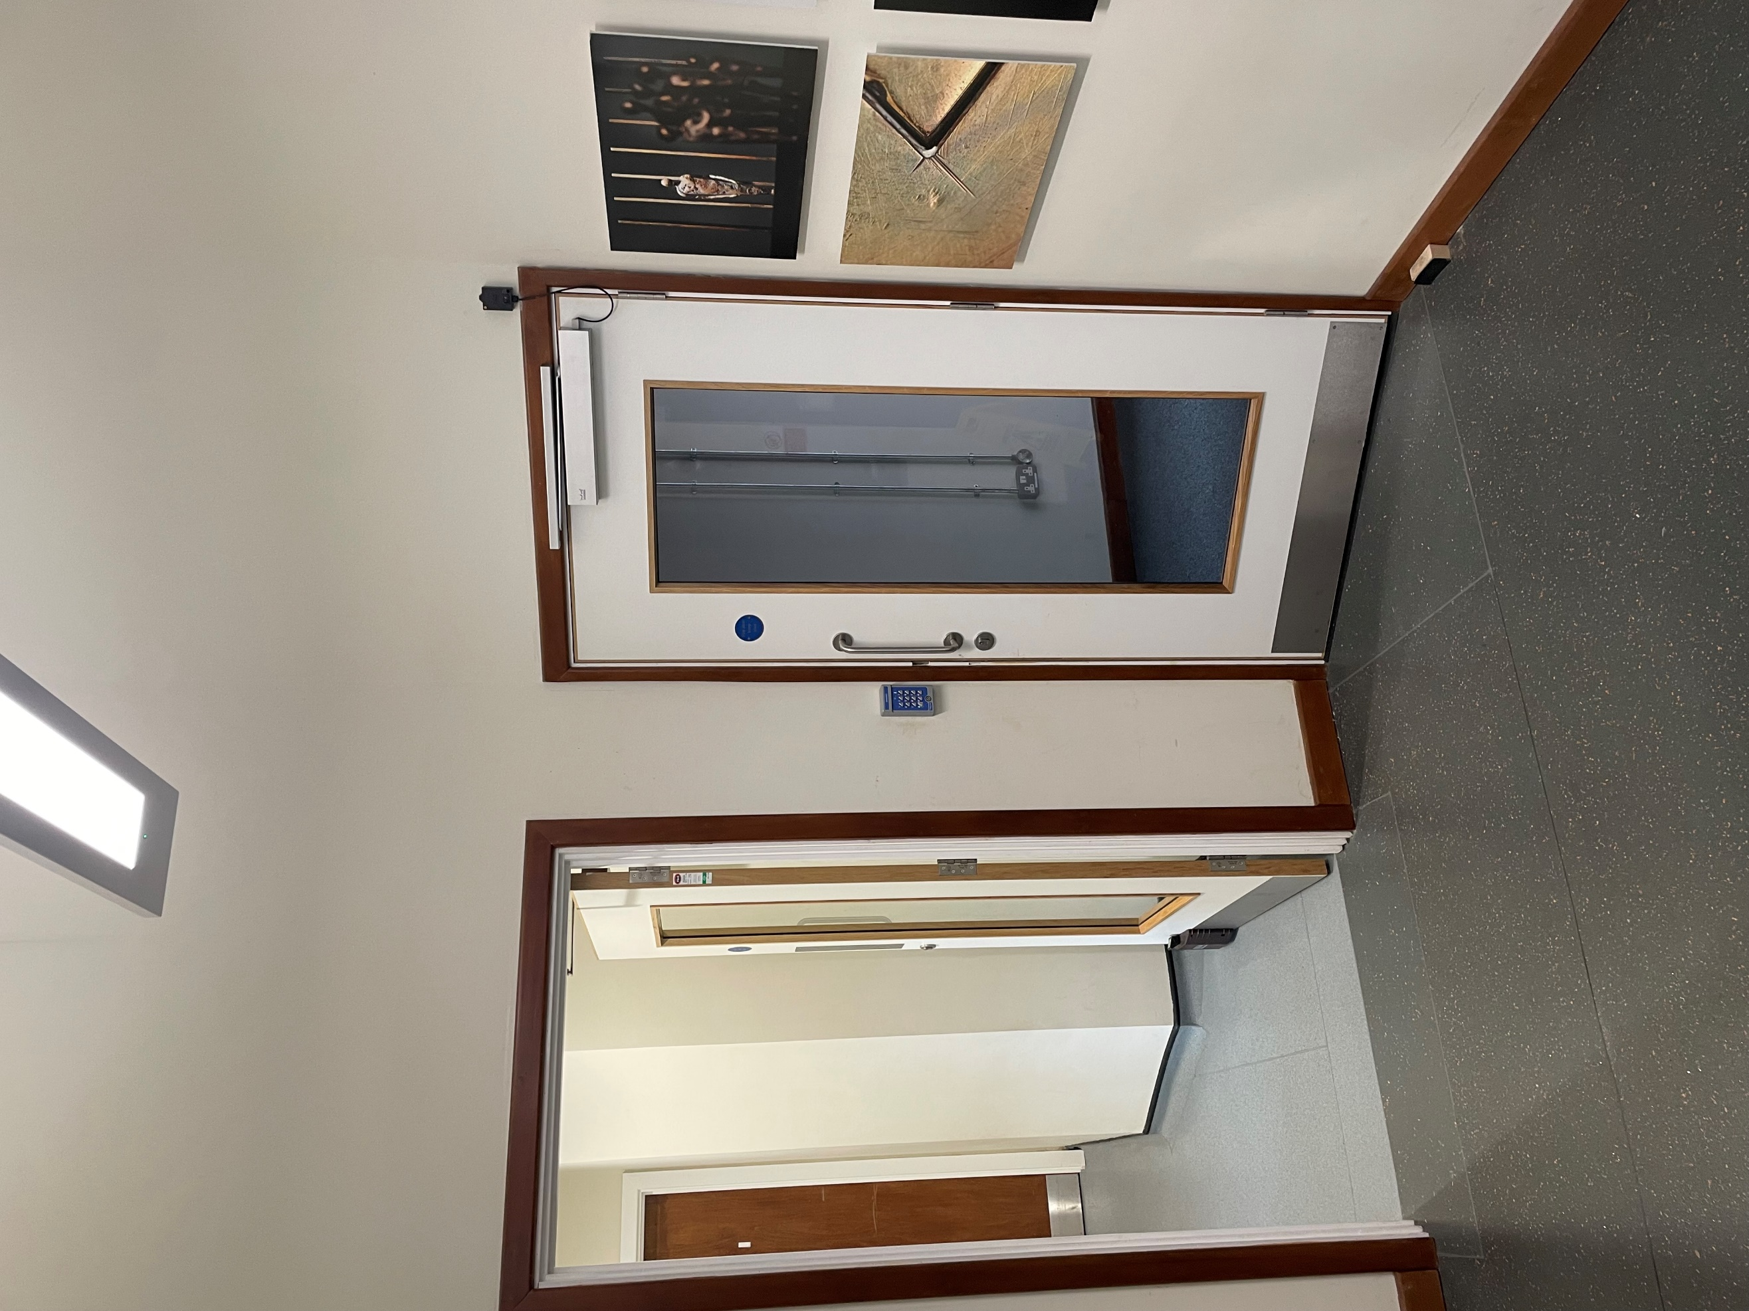

There are also two toilets on the 2nd floor. They are either side of the lift. The hand dryers in here can be turned off too.
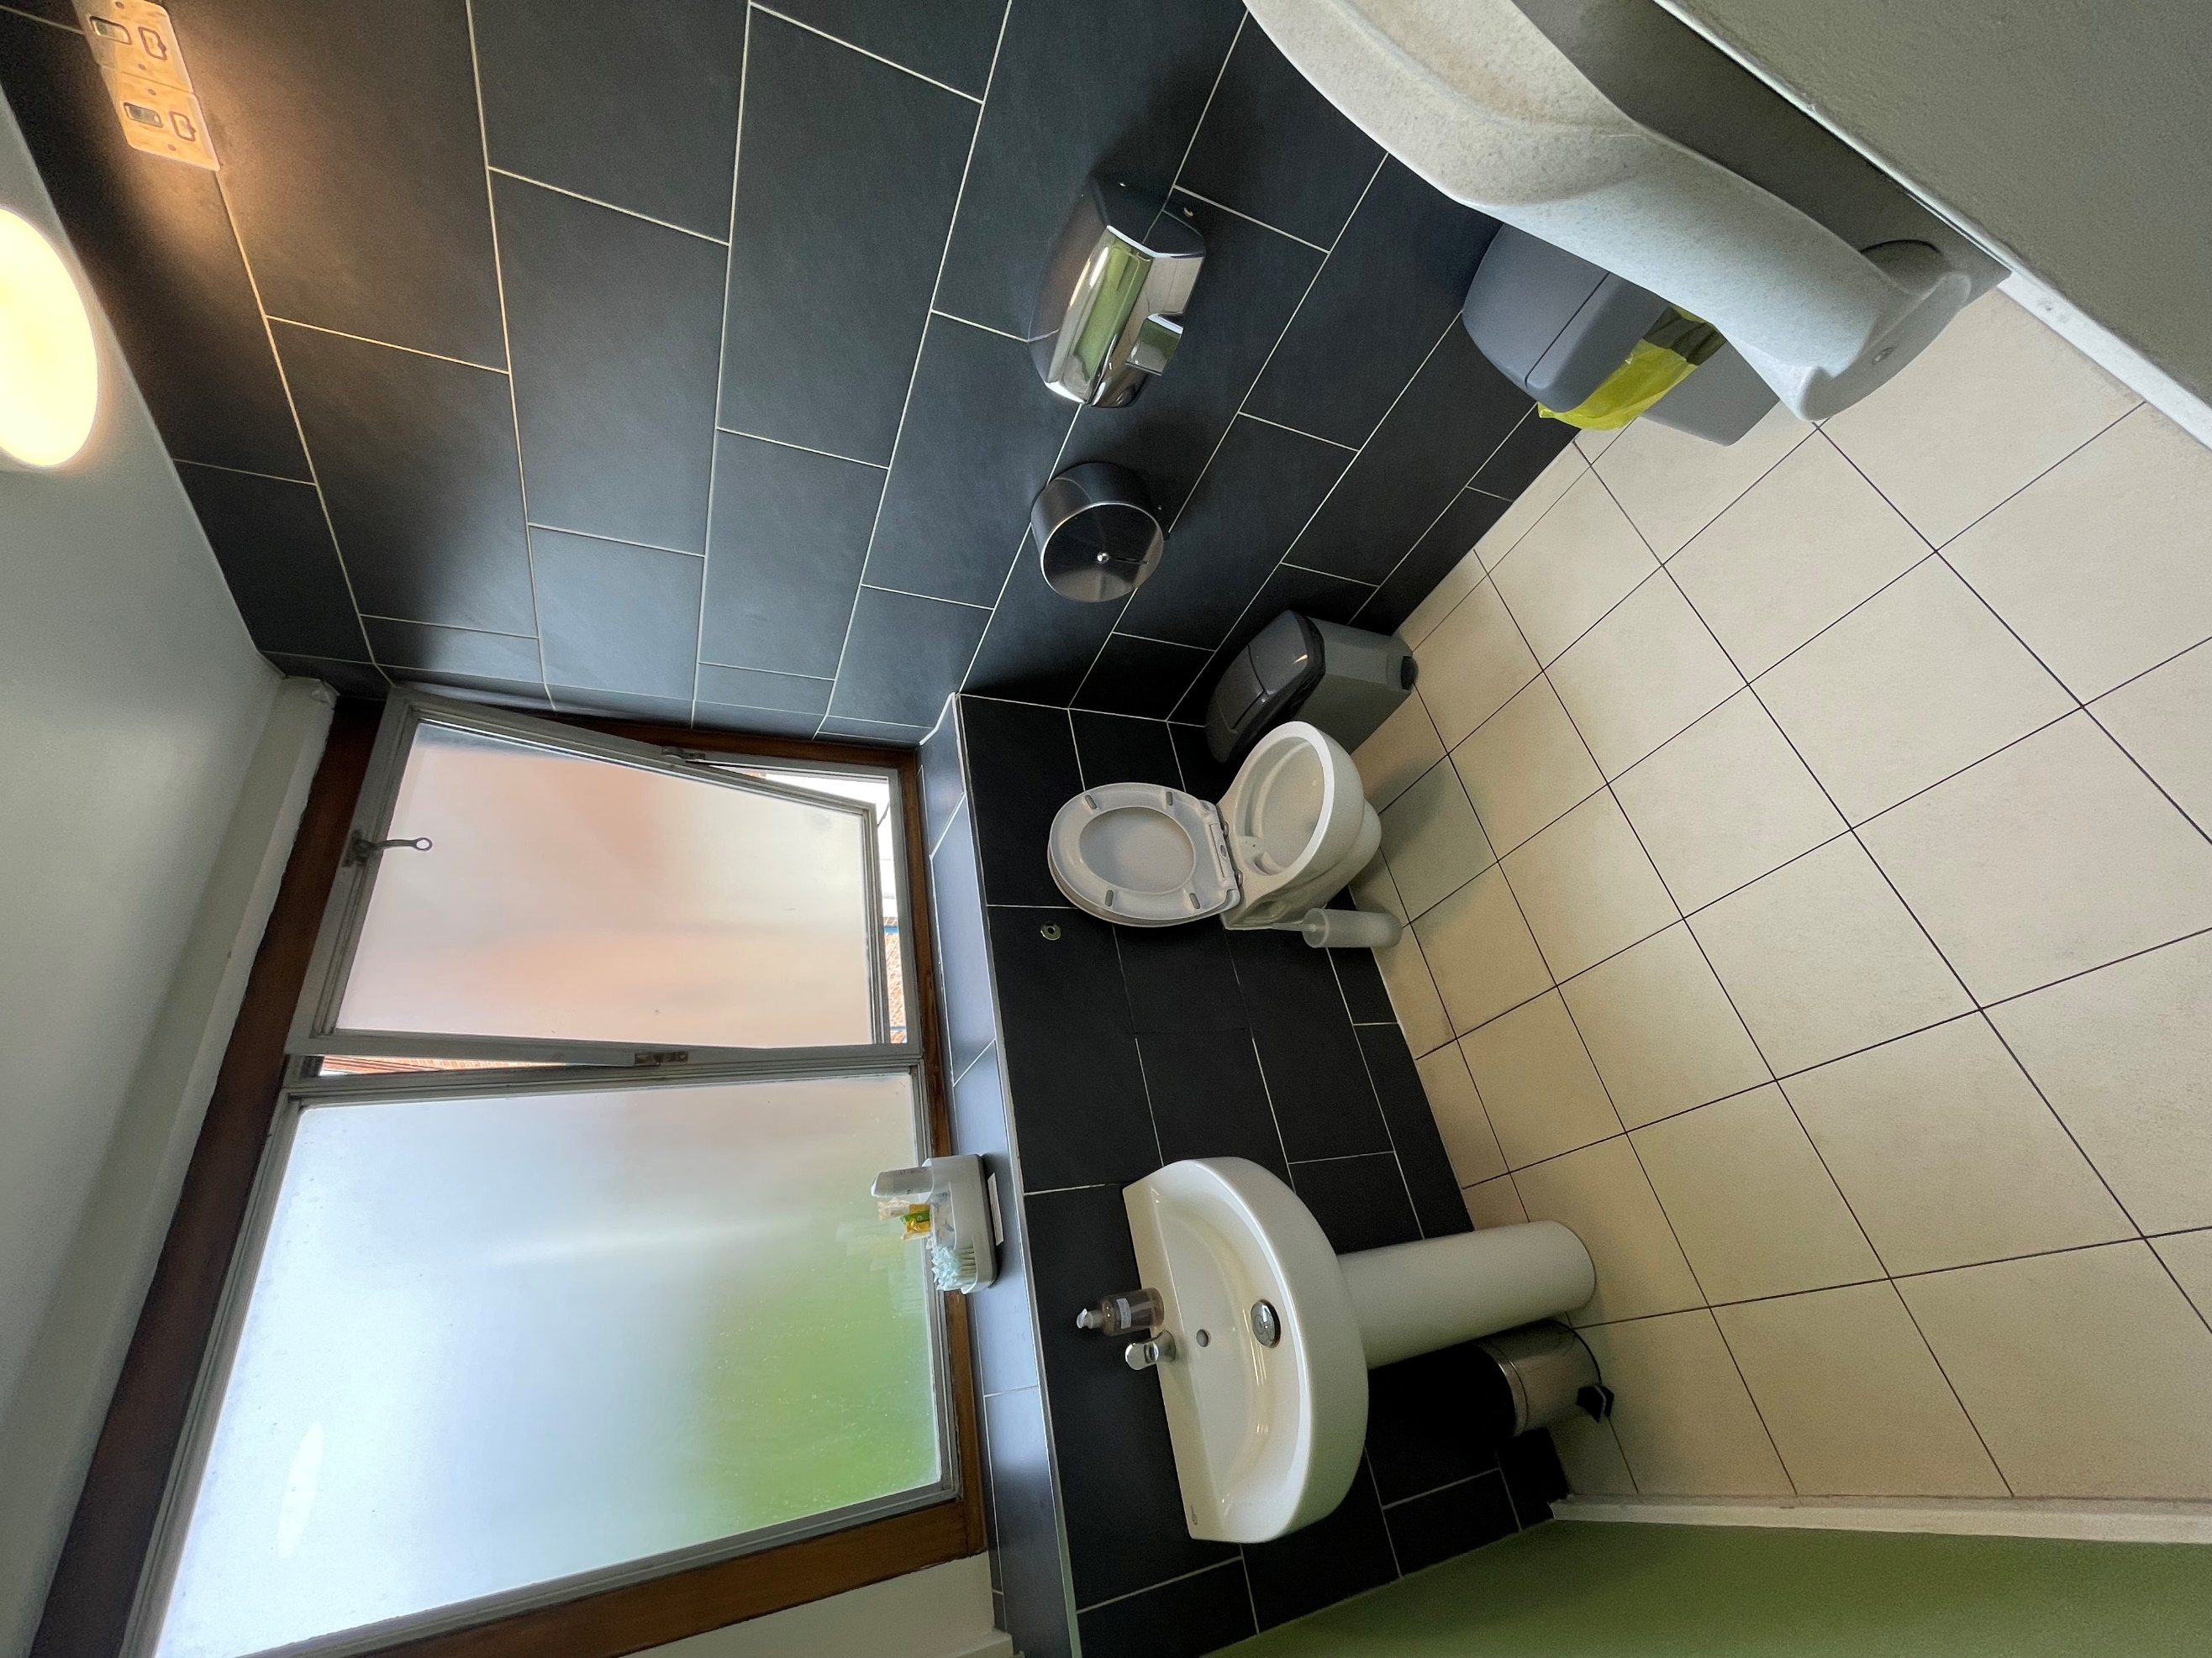
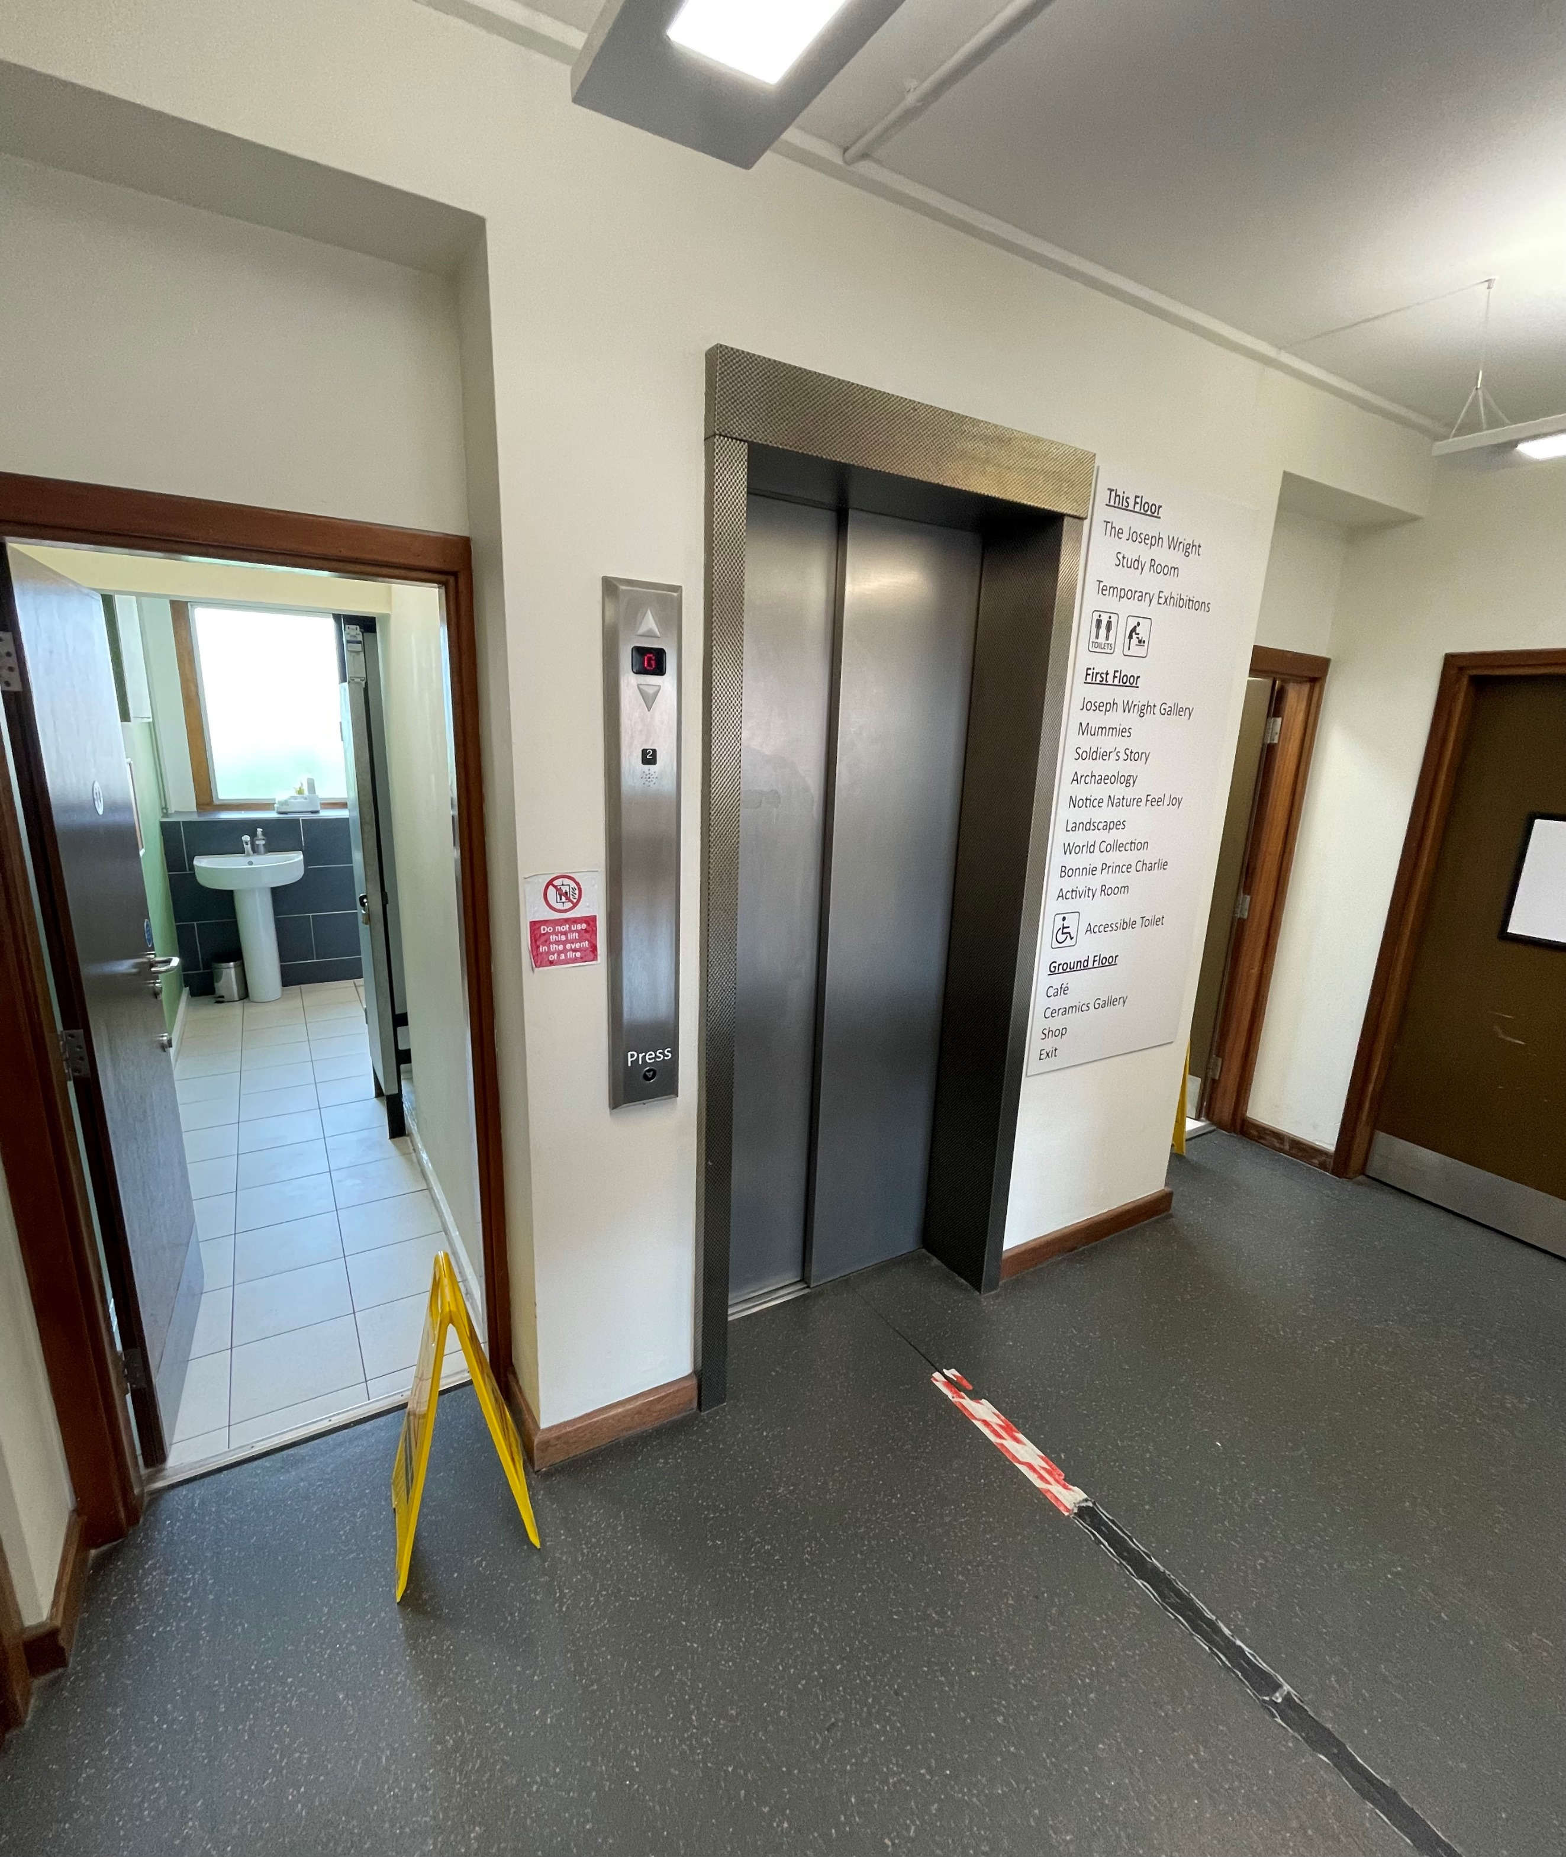

There is a sensory bag hanging in the lunchroom. You can use anything inside it if you want to.
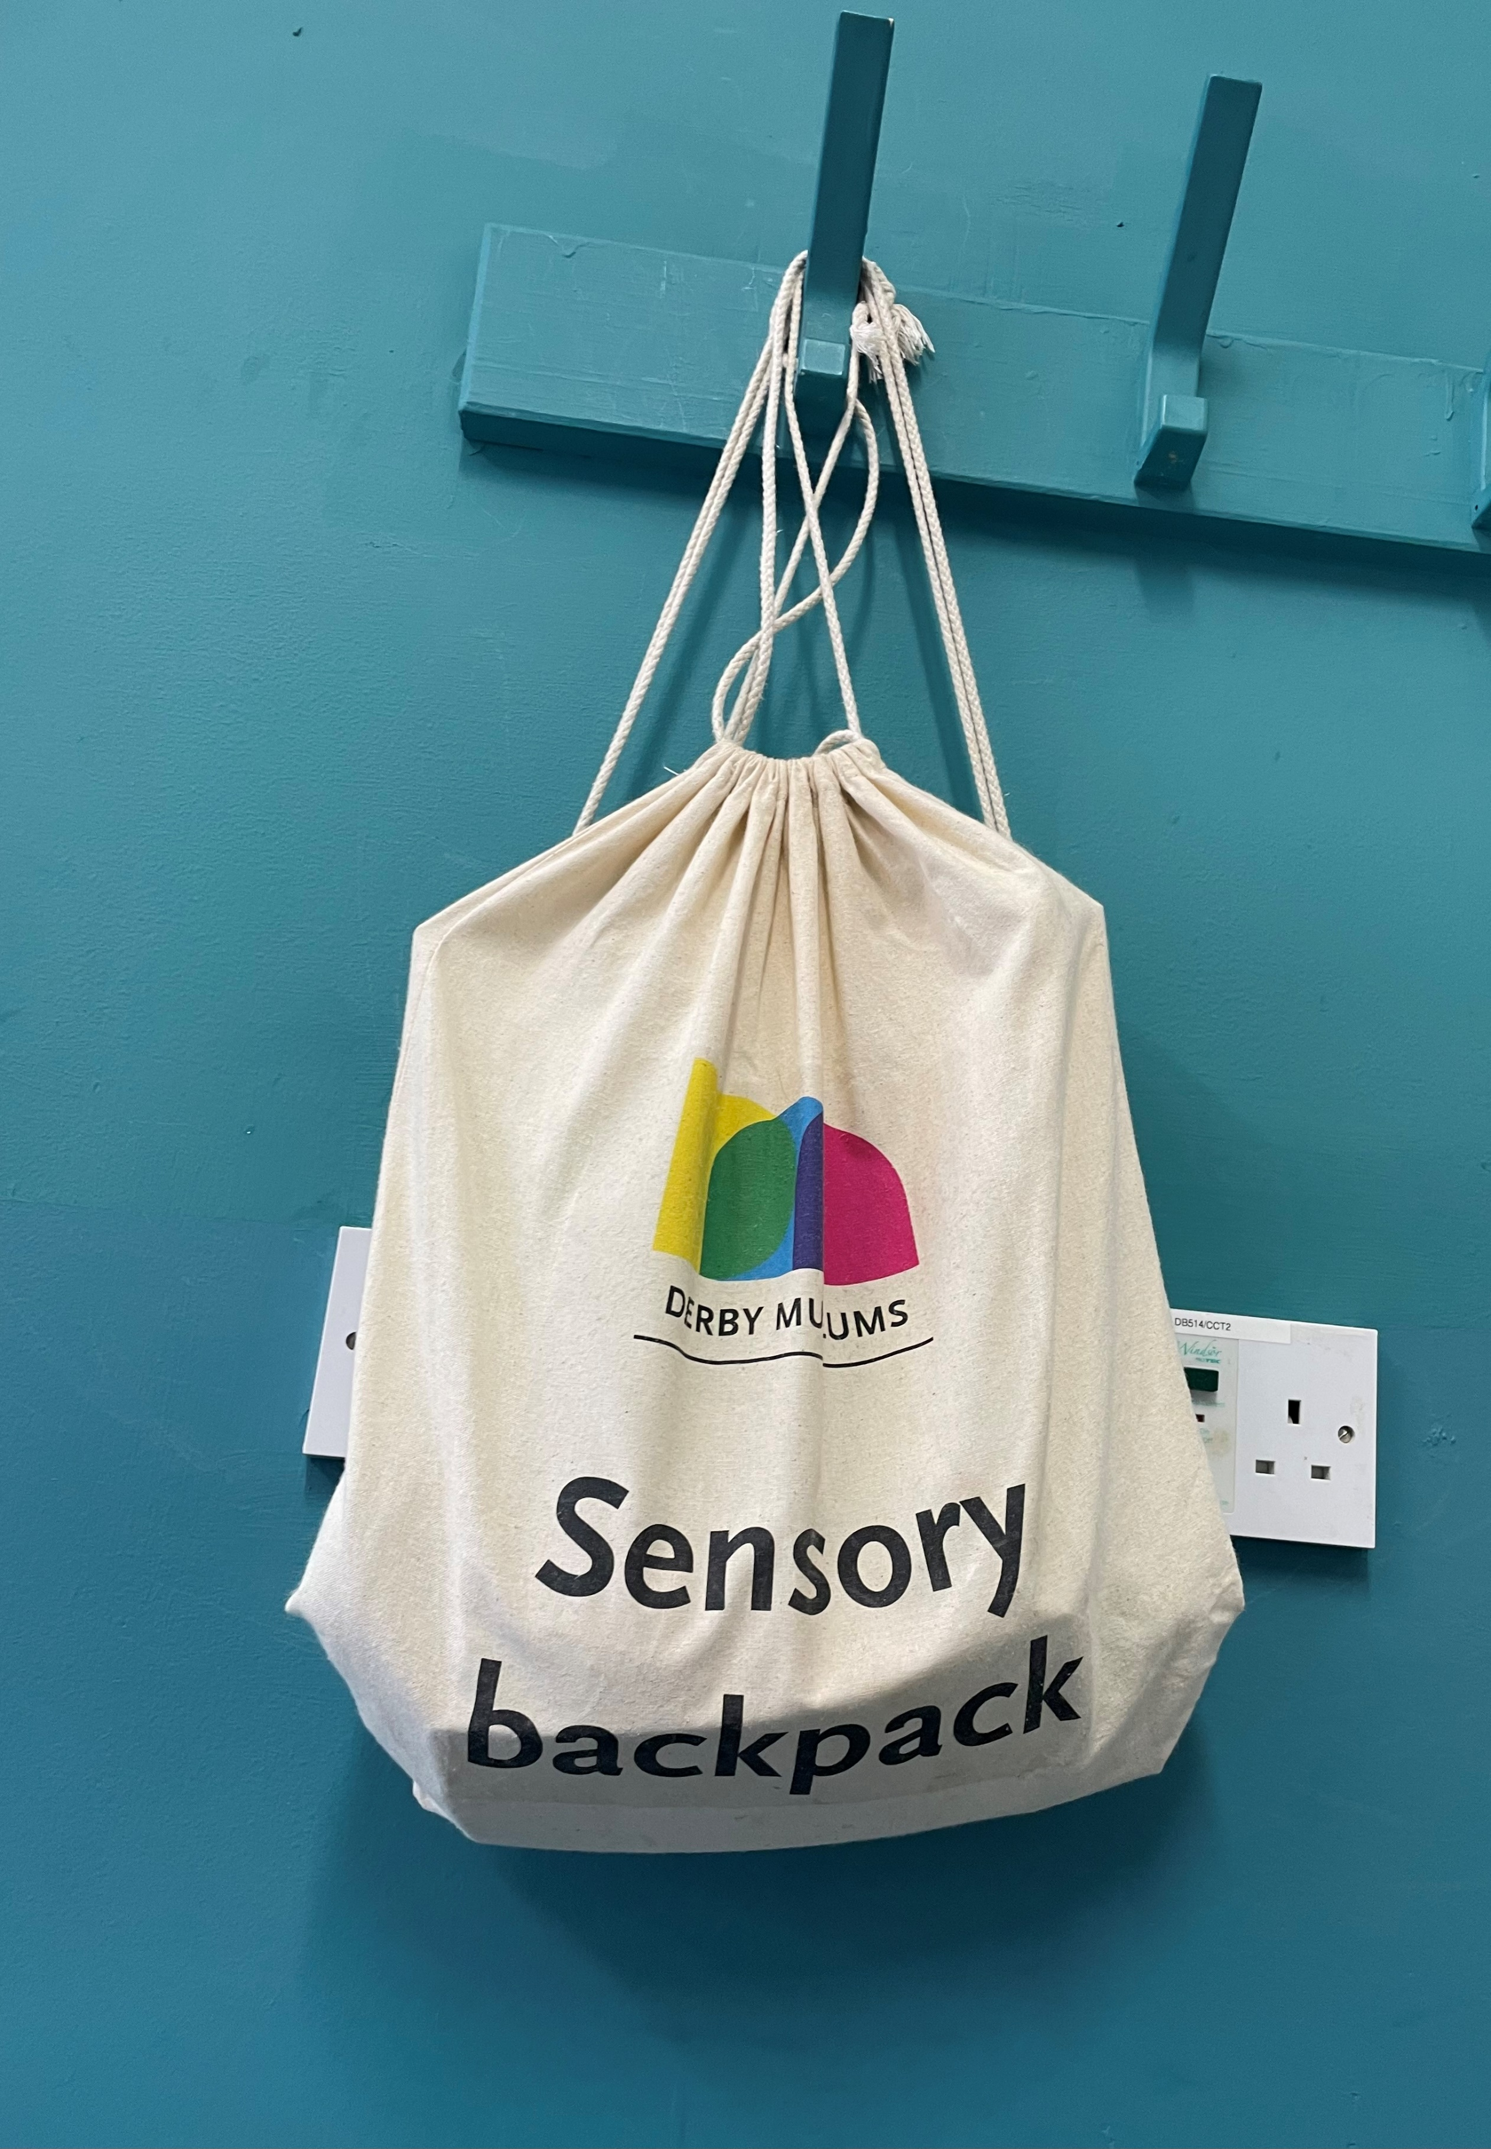

We hope you have a good time at Derby Museums!

Note for staff: We want everyone to feel happy and welcomed at Derby Museums. They’ll be a breakout room available for your use. If you need any help please ask any staff on the day of your visit.
The Viking session does have a long introduction (approx. 45 mins) and we’re aware that for all children, whether neurodiverse or neurotypical, that this is a long time to sit and listen. We are currently working on updating the session. The new session will be ready for November 2025 when the galleries are redeveloped- sorry it isn’t ready yet! We’ll aim for approx. 20-25 minute activity ‘chunks’ in the new session.
If you need any other help or further advice you can email learn@derbymuseums.org or or call 01332 641901 and ask for a member of the learning team and we’ll try our best to help.

