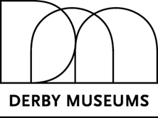

Equity, Diversity and Inclusion Statement

Equity, diversity, and inclusion are key to the work that we do. We believe in opening up access to the museum collections for all and acknowledge that there are a number of barriers to entry to cultural spaces encountered by many members of our community. We adhere to the Equality Act 2010, and we believe in the value of a diversity of voices in our work.
Everyone involved with Derby Museums Trust – whether staff, volunteers, stakeholders, or visitors – should be free to be themselves within our spaces. Museums are spaces where views and preconceptions are challenged through encounter, experience and discussion.
We uphold the protected characteristics of age, disability, gender reassignment, marriage and civil partnership, pregnancy and maternity, race, religion or belief, sex, and sexual orientation, while also acknowledging that employment status, class and cultural background should not form any barrier to entry or engagement with our collections, spaces, programme or outreach.
We are committed to creating an environment where the individual is valued for the unique voice they can bring to our work, and where people are free to self-express, irrespective of their background or identity.

